**SAP BW/BO Exercise**

**Exercise 2: BEx Query Designer – Create, Modify & Save Queries**

**SAP BW Login Id:**

**THE SCREENSHOTS IN THE DOCUMENT ARE ONLY FOR REFERENCE AND MAY NOT MATCH WITH THE VALUES YOU GET AS OUTPUT.**

**Note: You must use the following conventions to name objects/systems created in this exercise.**

**Replace S with A - for Fall semester**

**B - for Spring semester**

**C - for Summer semester**

**Replace YY with the last 2 digits of the current year.**

**Replace XXX with your SAP ID.**

**Objectives:**

Develop an understanding of a query as a set of defined attributes, characteristics and key figures used by the OLAP engine to create a report from the data located within the data warehouse.

**Query Designer**: Tool used to create, modify, save queries by utilizing data targets (infocubes & DSO) in SAP BW.

Access BEx Query Designer through your windows menu paths.

**Creating Queries**

Query Designer Tool: Let’s talk about the query objects and structures and then we will get some hands on practice using some of these components.

The following are the objects used to create queries in the BW Environment.

* Key figures
* Calculated key figures
* Restricted key figures – common method for limiting the amount of data returned
* Reusable key figures
* Characteristics
* Restricted characteristics
* Calculated characteristics
* Reusable calculated characteristics
* Structures
* Formulas
* Excel calculations
* Variables Hierarchies
* Navigational attributes

The above objects along with the two basic navigational functions known as filter and drilldown, you learned in the previous lesson, you should be able to design queries that meet most any business requirement.

**Note:**

* There can be a total of 16 dimensions to one InfoCube.
* 3 are reserved for Time, Unit of Measure, and Packet ID.
* 13 are user definable.
* There can be up to 248 attributes for a dimension

**What is a characteristic?**

**_____________________________________________________________________**

**_____________________________________________________________________**

**Navigation – BEx Query Designer**

**Please follow the below given path:**

Bex Analyzer🡪 Tools🡪 Create new Query (opens up query designer)

1. Navigate to the Query Designer window and provide the screen capture of the window you received.

**(Screen Capture goes here)**

1. Select/Open any Query from Info Areas and provide the screen capture immediately below.

**(Screen Capture goes here)**

1. Open BEx Query Designer. Click on Query🡪New 🡪Info Areas🡪 UA BI Curriculum 3.0🡪Master Copy🡪 GBI Reporting Master (Cube). Now, turn on the technical names and include screen capture.

**(Screen Capture goes here!)**

1. Within the Query Designer transaction, you are able to select the “Filter” and/or the “Row/Columns” selections. Name all nine of the windows in the Query Designer transaction.

**Name and describe each of the nine windows.**

* 1. Pane 1 ------------------------------------------------------------------------------------
  2. Pane 2 ------------------------------------------------------------------------------------
  3. Pane 3 ------------------------------------------------------------------------------------
  4. Pane 4-------------------------------------------------------------------------------------
  5. Pane 5-------------------------------------------------------------------------------------
  6. Pane 6-------------------------------------------------------------------------------------
  7. Pane 7-------------------------------------------------------------------------------------
  8. Pane 8-------------------------------------------------------------------------------------
  9. Pane 9-------------------------------------------------------------------------------------

1. Define the following:
2. **InfoProvider:**
3. **InfoArea:**
4. **InfoObject:**
5. **Dimension:**
6. **Characteristic:**
7. **Attribute:**
8. **Key Figure:**

**Create Query – BEx Query Designer**

1. Now open Query Designer: (BEx Analyzer🡪Tools🡪Create New Query). In Query Designer, load the Cube by navigating through: Query 🡪New 🡪Info Areas🡪 UA BI Curriculum 3.0🡪Master Copy🡪 GBI Reporting Master (Cube).
2. Define your query with the following elements:

* Filter: Calendar Year = 2011. Country = United States
* Rows: Product Category and Material
* Columns - Key figures: Sales Quantity, Revenue, Discount and Cost of Good Manufactured

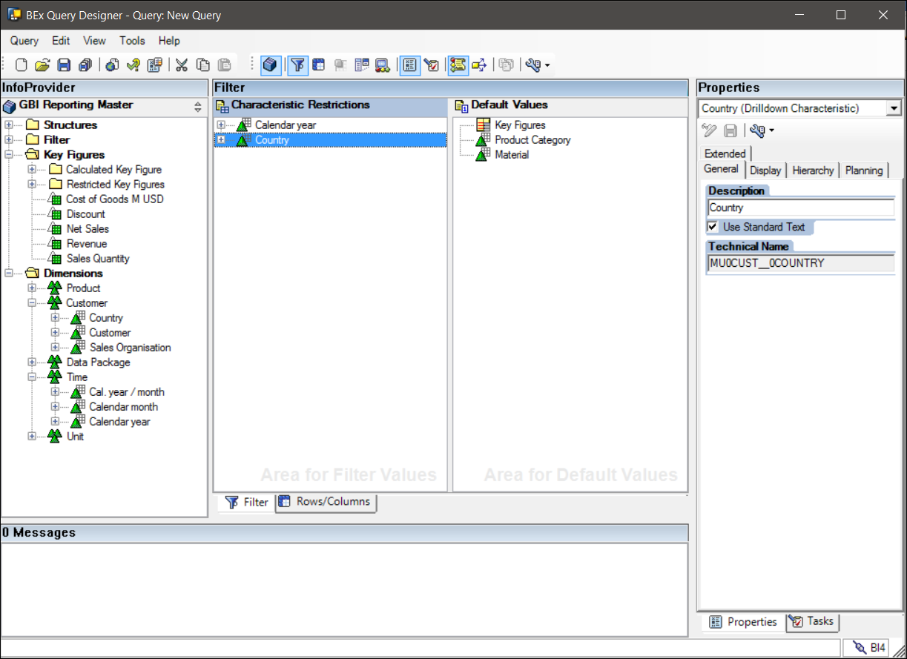

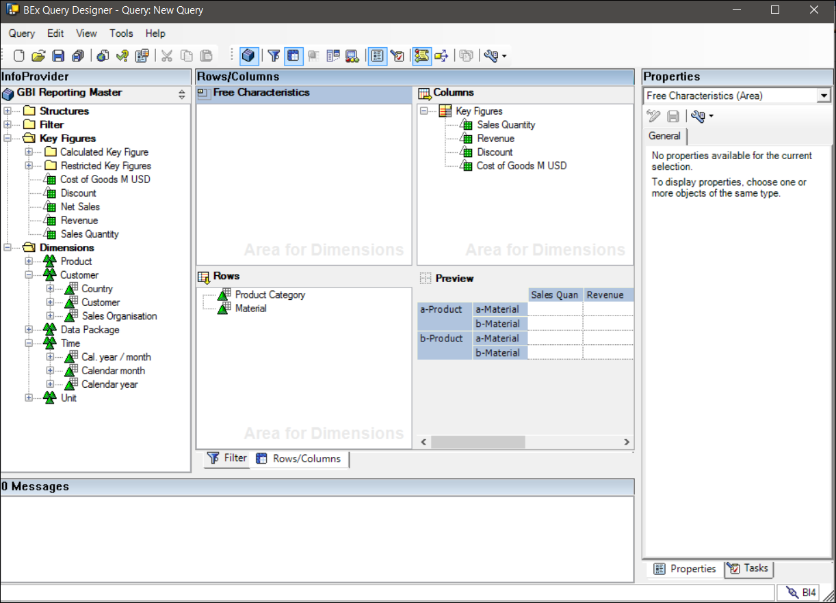

Save the Query with Description as (Your first name SYYXXX) and the technical name as (QTRCCSYYXXX). Test your query.

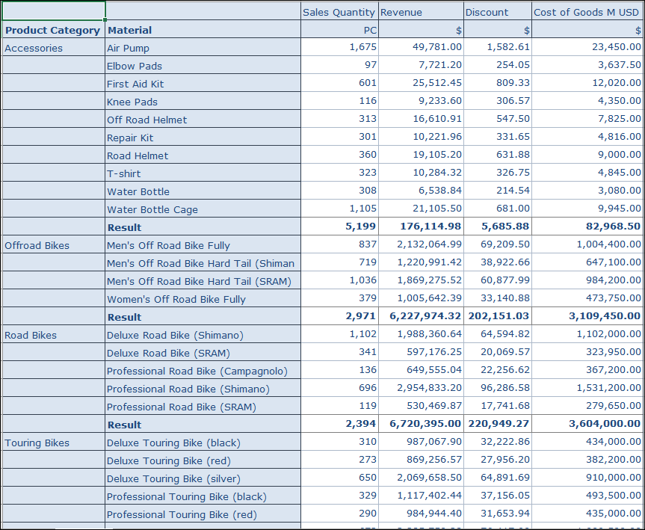

**Paste a screenshot of your query executed in excel.**

**Display as Hierarchy**

1. Add *Customer* to the rows (c.f. steps above). Change your query, so that the rows are displayed hierarchically. Expand to level *Material*. To achieve this:
   1. Click on *Rows*
   2. Under Properties, check the *Active* box for Display as Hierarchy
   3. Choose the level to expand accordingly.

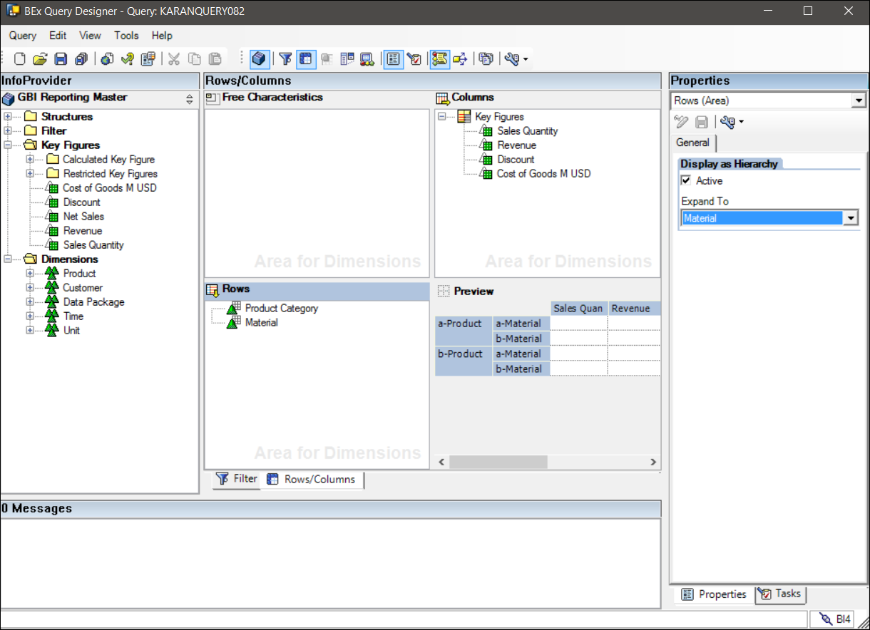

**Paste a screenshot of your modified query executed in excel.**

**Selections**

1. **Selections** can bind filter conditions directly to a key figure in our query. For example, it can show not only revenue but planned revenue for previous month. This is often used for comparisons between plan and actual.

Change your query again: Remove the filter for *Calendar Year* andremove all key figures except *Sales Quantity*. Use the technique of selections to compare sales quantities of Q4.2011 with Q4.2012. Double click on key figure *Sales Quantity* and drag calendar months 10.2011 to 12.2011 from left to right (1) on the following screen. Rename it to *Sales Q4.2011*

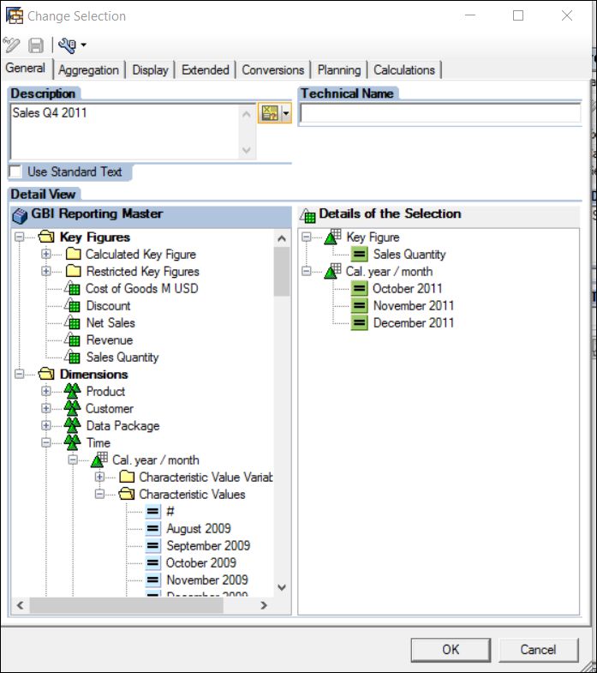

Now similarly, add key figure Sales Quantity to your query again. Double click on it and repeat the previous step for months 10.2012 to 12.2012.

**Paste a screenshot of your query after selecting sales quantities of Q4.2011 with Q4.2012.**

**Would this comparison of sales data be possible with common drill down techniques? Please justify your answer.**

**Answer**:

**Exceptions**

1. Exceptions are important for visualization of status and trends in data. They are comparable to conditional formatting in MS Excel. Furthermore, they can be used as a rule base automated trigger for alerting end users.

Change your query again: Add a formula for calculating the relative change in sales quantity between the two quarters Q4.2011 and Q4.2012. Right click on key figures, choose New Formula and then define the following formula for the relative deviation.

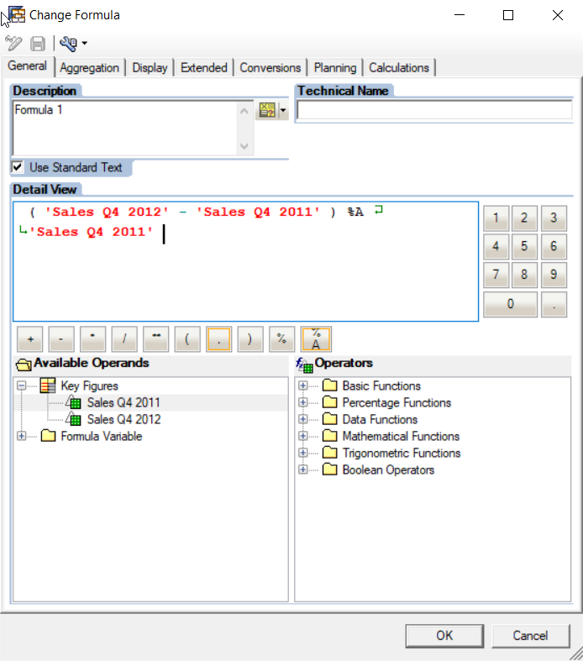

1. Define an Exception based on the following rule:

* All changes above +15% green
* All changes below -10% red

In Query Designer choose button Exceptions (little traffic lights) .

Then choose *New Exception* with right click:

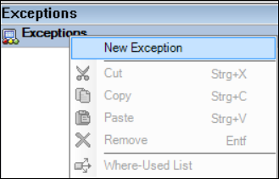

On the following screen you must define the rules:

* First choose button *New*
* Define the rule with Alert Level *Good 1*, Greater than Operator and value = 15
* Click on Transfer and then click on Ok.

Repeat these steps for the second rule with alert level *Bad 1* accordingly.

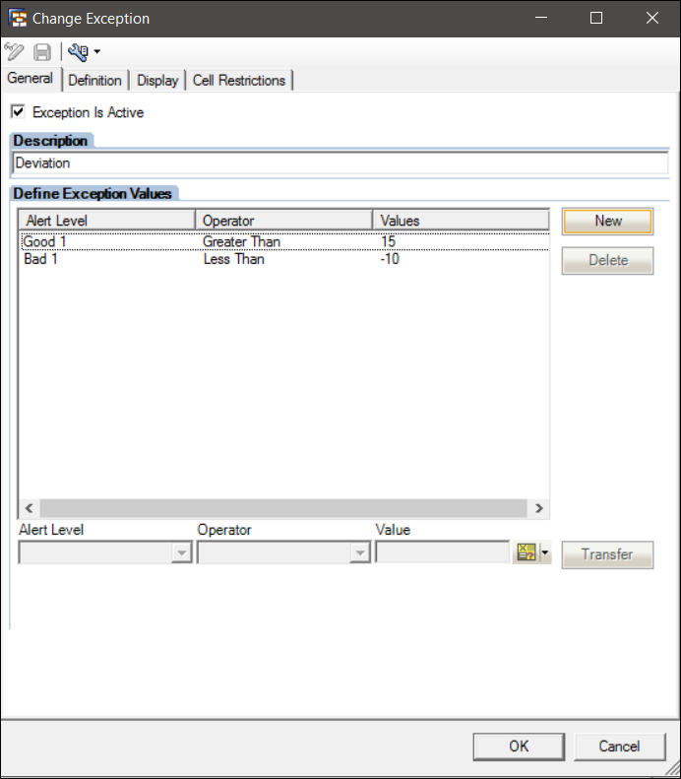

1. On the second tab Definition, you must restrict your exception rule to the formula created in the previous step.

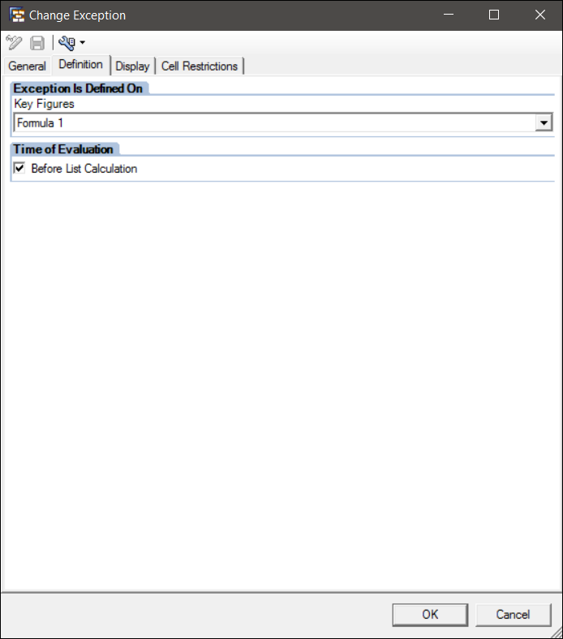

1. Click OK. Save your query. Run your query again.

**Paste a screenshot of your query executed in excel after highlighting the exceptions .**

**Conditions**

1. Go back to Query Designer. Change your query:
   1. Remove Product Category.
   2. Show only the 5 most important products based on Revenue.
   3. Add Revenue to query**.** This will be achieved by using conditions with the Top N operator.
   4. Choose the Conditions button and right click New Condition.

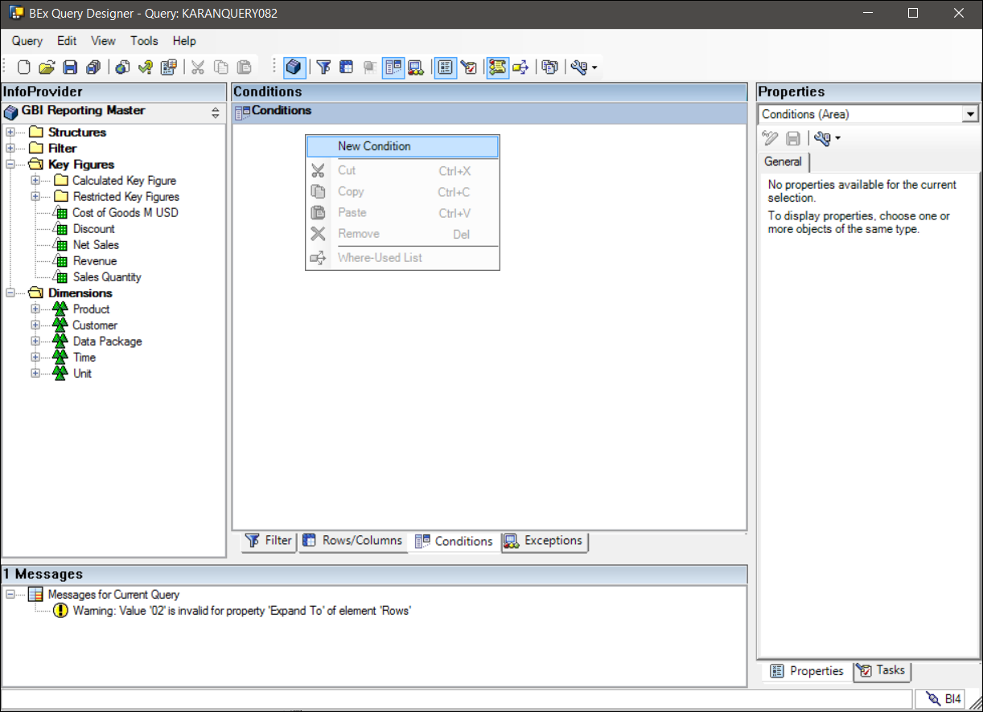

1. The Conditions dialog box is similar to the Exceptions dialog box: You can specify the key figure, an operator and value(s). Click *New*, define the condition and click *Transfer*.

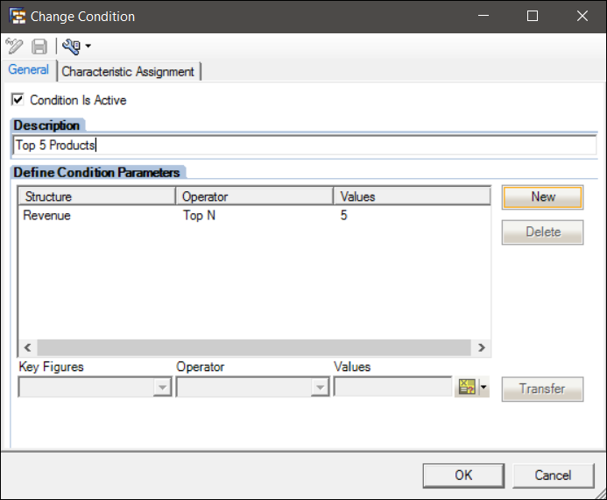

**Paste a screenshot of your query executed in excel after displaying Top 5 products based on Revenue.**

1. Set the Top N condition to inactive. Define a new condition with the following values: Use formula *1*, operator *Less than* and Value *0*.

**Paste a screenshot of your query after displaying products with decreasing sales.**

**Variables**

Variables are powerful concept to make queries more flexible, reduce the number of queries and personalize query filters. In this exercise, we will demonstrate two use cases for variables that replace a characteristic value. In SAP BW, there are other variable types such as texts, hierarchies or formula elements.

**Variable Without User Input (Processed by Customer Exit)**

1. Change your query again: Change the filter for *Country*. Instead of having a fixed value "US", use variable *BI Curriculum: Country based on User Name* (technical name ZVAR_COUNTRY_XXX):

In Query Designer, go to the *Filter* tab, remove filter for *Country*, expand Country in Dimensions, right click on Characteristic Variable Values and select New Variable. Enter the following details:

* Description: *BI Curriculum: Country based on User Name*
* Technical Name: ZVAR_<Name>_COUNTRY_XXX **(Not Unique)**
* Processing by: Customer Exit
* Reference Characteristic: Country

Click OK. Drag the variable *BI Curriculum: Country based on User Name* (technical name ZVAR_COUNTRY_XXX) onto Characteristic Restrictions *Country*.

XXX will be your SAP BW ID.

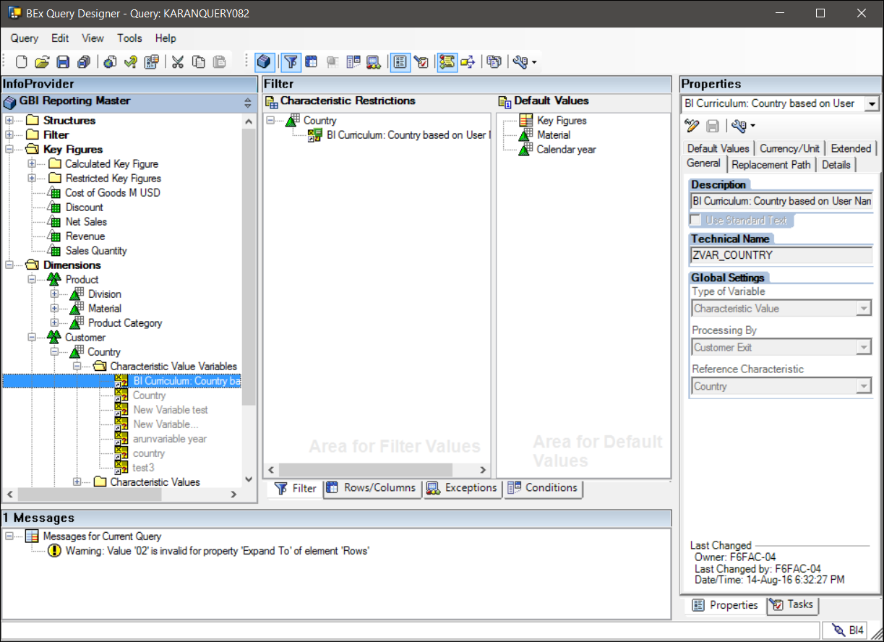

1. Save and test your query.

**Paste a screenshot of your query executed in excel after filtering it with a variable (processed by customer exit).**

All students having a user id ending with an odd number should get *Country* = US, all user ids ending with an even number or ending without a number should get *Country* = DE. This is determined in a customer exit program. In real life, this is usually determined by the user's authorizations**. (Select Country As per your id ending in Odd or even number)**

**Variable for Manual Input**

Many variables provide values to parametrized queries. The user is prompted to type in values when the query is executed. As an example, use currency conversion type that gets To-Currency from a variable.

1. Change your query again: **Add *Revenue* to the columns** (choose *Always show* in the properties). Use Conversion Type *BI Curriculum: Variable To Currency*: To do this,

Select *Revenue*, tab *Conversions*, choose Conversion Type *BI Curriculum: Variable To Currency*.

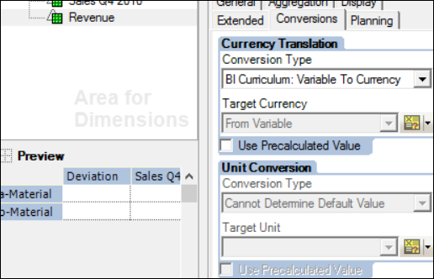

Test your query. A user prompt where you can type in the target currency is displayed before the query is processed.

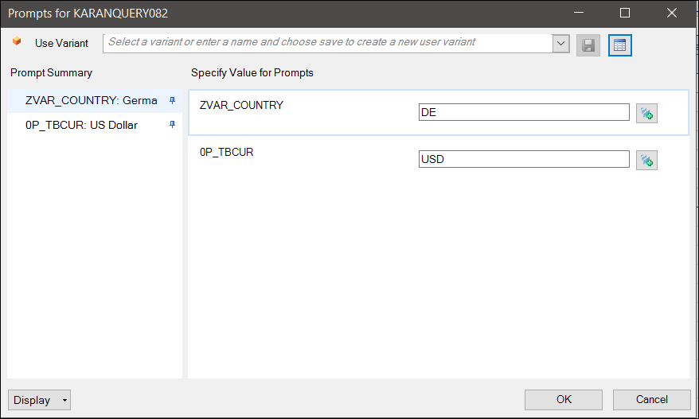

**Paste a screenshot of your prompt box where Country = US and Currency = Eur.**

Check the Query and Save the query as a **new query** using the name “your name Variables” and Technical Name = “BWUTDSYYXXX1” whereas “XXX” is your SAP BW ID

**Description: ________________________________________**

**Technical Name: ____________________________________**